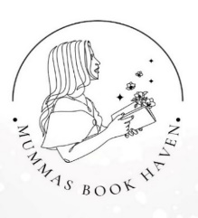
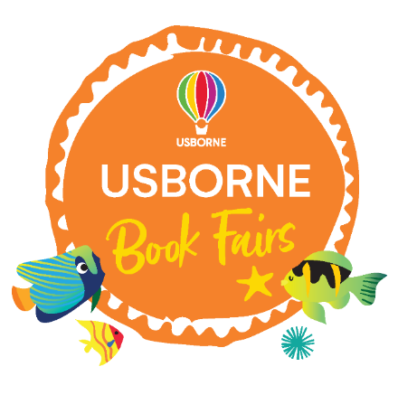


Dear Parent/Guardian,

With Christmas approaching we would like to continue to promote reading for pleasure and encourage our pupil’s literacy development at home. Therefore I am pleased to say that we are hosting a Book Fair which is being organised in conjunction with our local Usborne Partner, Danielle Theodosiou, from “Mumma’s Book Haven” who will have a range of fiction and non-fiction books, games and activities, including book related Advent calendars and puzzles so you can do some Christmas shopping too!

Every book purchased will go towards brand new FREE BOOKS for our school as Usborne will donate up to 60% of the total book fair sales in free books of our choice. So, for every £10 of books purchased, we could get £6 in FREE Usborne books for our school!

Date; Thursday 20th and Friday 21st November

Time; 3.15pm – 4pm

Where; School Hall

How; As it is close to Christmas, everything will be available to purchase and take home on the day, however if there is something you want that is not available, or you want fresh or multiple copies, then Danielle will take an order which you will receive back at school w/c 1st December with free delivery.

If you would like to order and are in a rush, please add your order form to the express box which will be available on the day and Danielle will contact you directly with a secure payment link.

What if I cannot attend in person?
Scan the QR code below or follow the link that has been sent out – online orders will only count towards the school free books if you select the link for Brooklands Federation. You can browse the whole Usborne catalogue at your leisure from now until 10pm on Sunday 23rd November, order books and pay securely online. Please select delivery via your Usborne partner to get Free Delivery and make sure you add your child’s name and class when prompted.

If you would like any recommendations you can visit Danielle at the Book Fair where she will discuss your needs with you, or you can contact her directly on the details provided below.
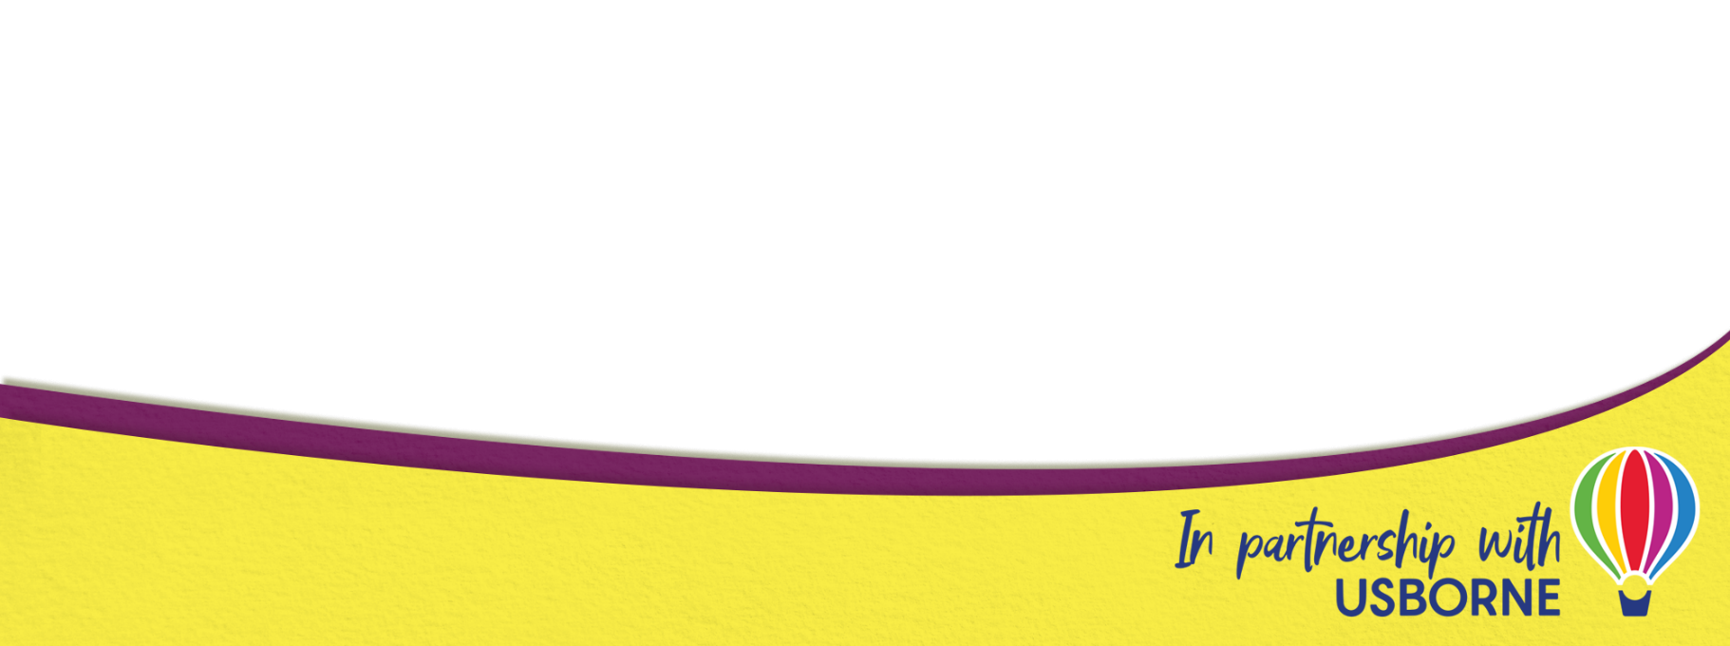
We hope you find lots of wonderful books for your family and we look forward to having lots more books for your child to read, share and enjoy at school.

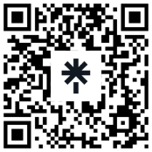
For more information, to browse the books ahead of the fair or for tailored book recommendations for your child, please scan the QR code or contact:
Danielle Theodosiou
Mummas Book Haven
07985443189
mummasbookhaven@hotmail.com

